## Trello Board Pictures

Picture 1:

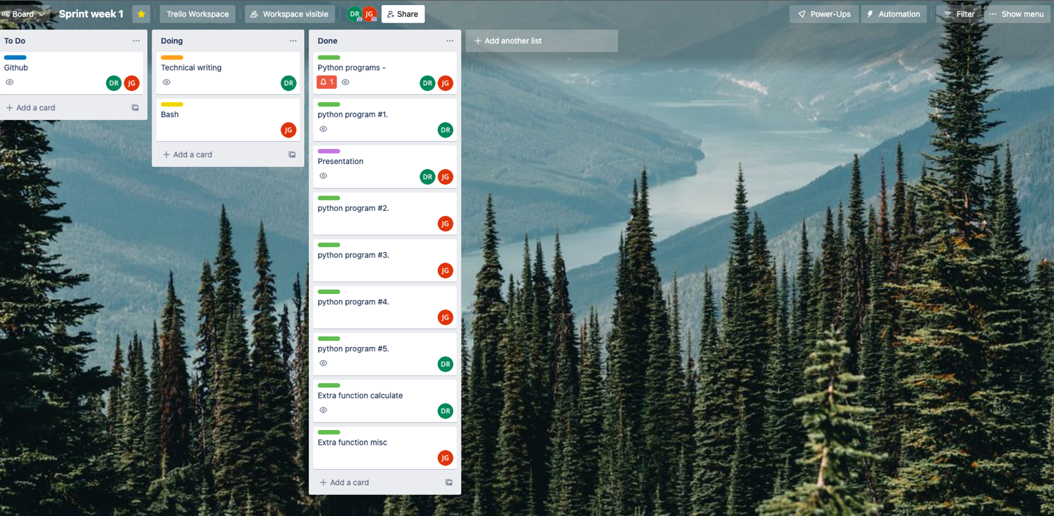

Picture 2:

Picture 3:

